CST STATEWIDE PROJECT DIRECTORS’ MEETING AGENDA
Tuesday, April 14, 2015
8:30 A.M. – 3:00 P.M.
Holiday Inn Hotel and Convention Center
1001 Amber Avenue, Stevens Point, WI
Phone: (715) 344-0200

8:30 A.M. | Check In and Registration – Expo 1  Refreshments and coffee will be available
9:00 A.M. | Welcome, Introductions, and Announcements  Teresa Steinmetz
9:50 A.M. | Break
10:00 A.M. | General Session – Expo 1  Values In Action: Keeping it Real  Ann Kelley-Kuehmichel
10:50 A.M. | Break
11:00 A.M. | Breakout Sessions and Focus Group
Frontier Room  Integrating Services and Funding Opportunities Focus Group  Joanette Robertson, Teresa Steinmetz, Dawn Campbell, and Sally Raschick | We want to hear from you! We know that integrating services and funding sources in children’s mental health care is important but can be a struggle. This focus group is designed to ask for your input regarding what’s working and what’s not working in this area to help us make the best decisions moving forward to provide assistance. This session is not designed to answer questions, rather to assist in making a plan to address needs with the best approach.
Evergreen Room  Diversity, Working with Native and African American Families  Myrtle Long and Margaret Jefferson | Join us for a Round Table discussion of working with diverse families. Bring your questions and a case scenario to discuss with the group that will include experts and seasoned CST coordinators. Let’s learn from each other!
Expo 1  Advanced Team Facilitation Skills  Dan Naylor | Participants will engage in training and discussion regarding the skill set necessary for effective facilitation, including the challenges that teams face and the facilitation skills necessary to meet them; and how to analyze team effectiveness; and steps necessary to deal with conflict before it destroys the team.
12:00 P.M. | Working Lunch – Expo 2  Lunch will be Provided
1:00 P.M. | General Session – Expo 1  SMART Objectives: Writing Work Plans and Plans of Care  Michael Derr and Barb Gang
1:50 P.M. | Break

2:00 PM | Breakout Sessions and Focus Group
Evergreen Room  2014 Expansion Grantees First Year Development and Next Steps Focus Group  Rebecca Wigg-Ninham, Kristin Allen, and Lucas Moore | We want to hear from you! How was the first year? What went well and what were your accomplishments? What didn’t go well and in what areas do you need support? What are your next steps and how can we support your success? Come share and learn from each other while teaching us the ins and outs of starting or revamping your initiative.
Expo 1  Child and Adolescent Needs and Strengths (CANS) Puzzle Strategy  Lori Martin and Amy Polsin | Learn how to use the “puzzle strategy” as a tool to link the CST CANS assessment process to the development of an effective, strength-based, and person-centered plan of care.
Frontier Room  Motivational Interviewing  Laura Saunders | Motivational Interviewing (MI) is an evidence based style of communication. At its core is a partnering, person centered and empathic approach. It specifically communicates a deep respect of autonomy of the child/youth and family. In our time together, we’ll discuss exactly what MI is and how it differs from other styles of communication. There will also be a brief exploration of the evidence and information on the pathway to learning MI for CST staff.
3:00 P.M. | Adjourn

Next Statewide Project Directors’ Meeting: Wednesday, September 9th, 2015
Holiday Inn Convention Center in Stevens Point

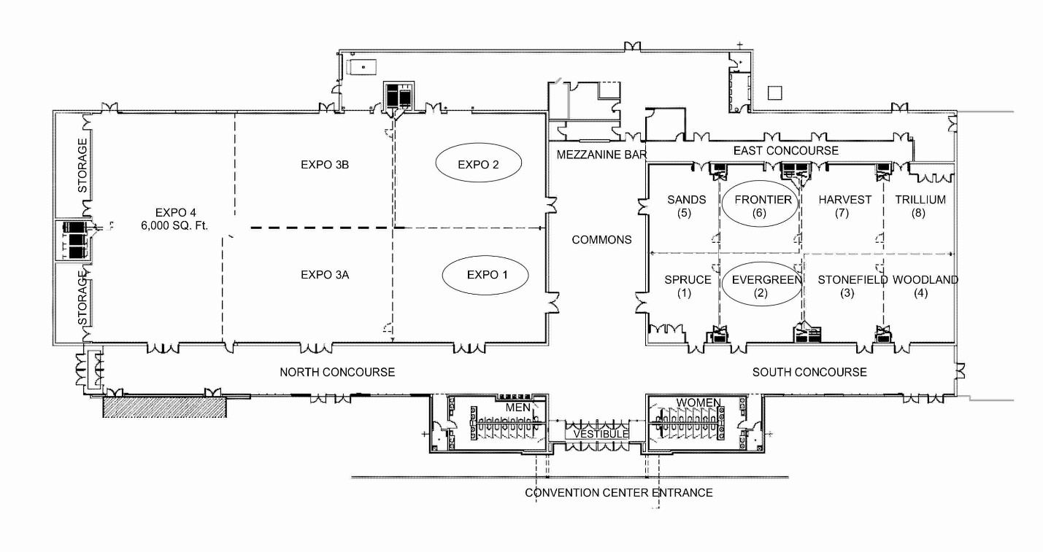

Holiday Inn Convention Center

