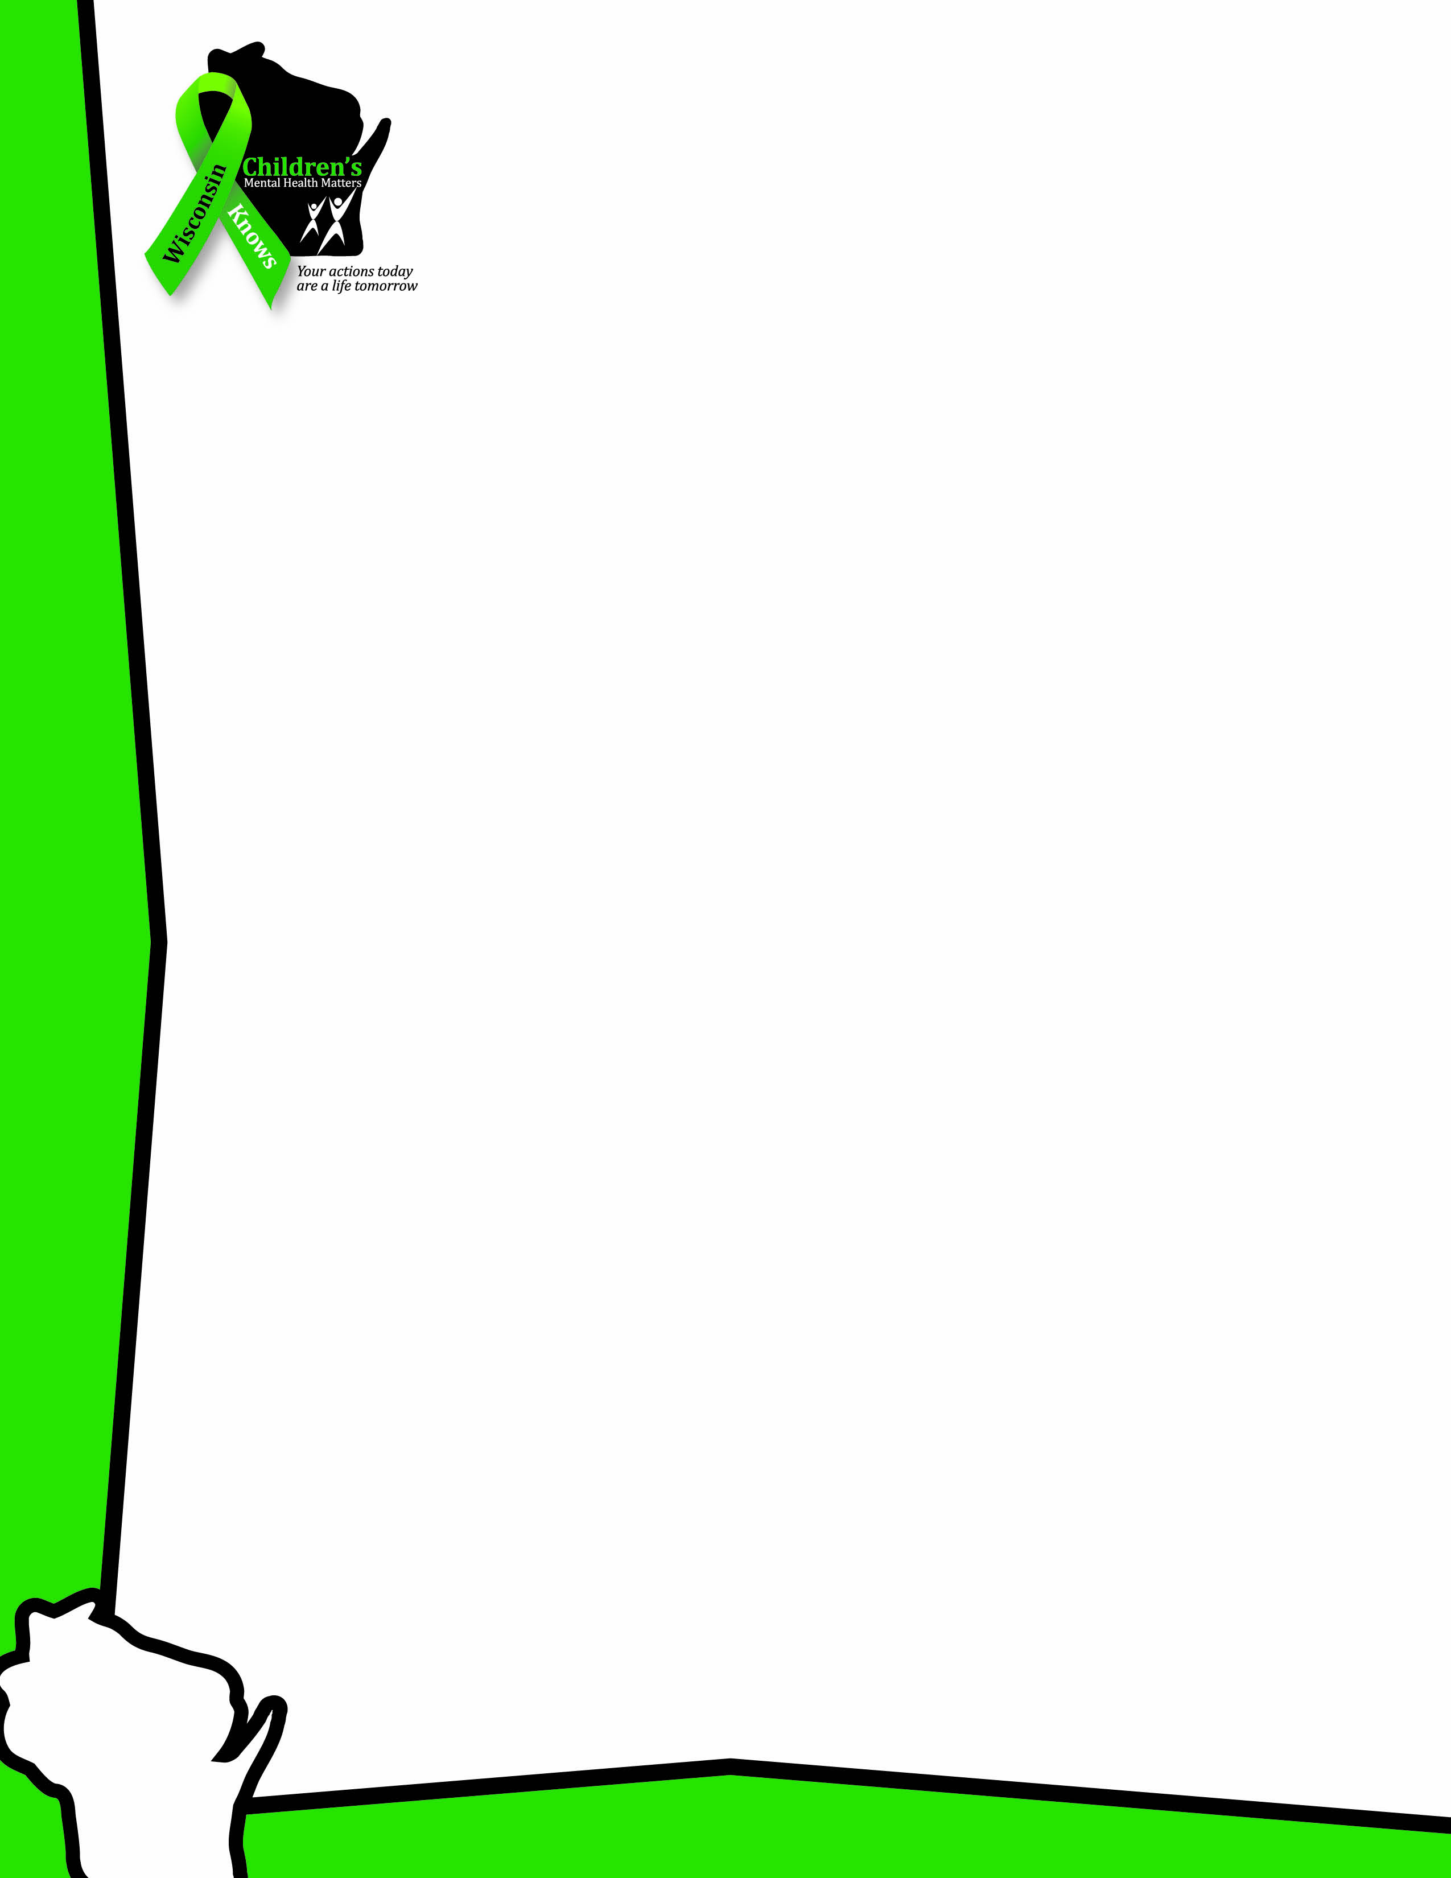
CHILDREN’S
MENTAL HEALTH
AWARENESS DAY
CELEBRATION

May 7, 2015
1 – 2 p.m.

Overture Center for the Arts
201 State Street
Downtown Madison

All are welcome!

- Presentation of a proclamation from Governor Walker
- Entertainment from youth groups
- Recognition of the “My Feelings Matter” poster contest winners
…and much more!
Organized by the Wisconsin Children’s Mental Health Matters Coalition, a team of representatives from non-profits and state agencies invested in supporting children’s mental health.
wisconsinknowschildrensmentalhealthmatters.wordpress.com

