Introducing…
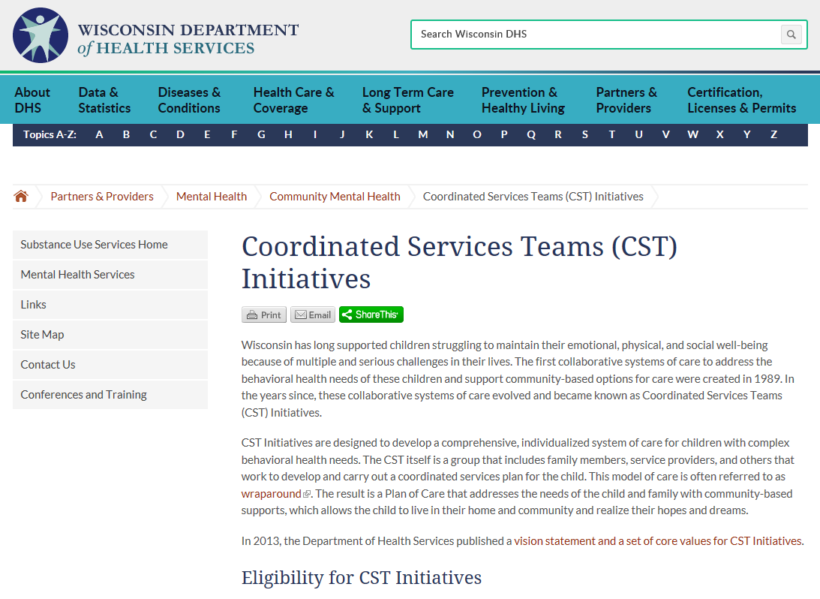
We’ve updated our CST Initiatives webpages. Update your bookmarks!

dhs.wisconsin.gov/cst/index.htm

The new “home” for CST Initiatives on the DHS website!
- General overview of the program
- Links to consumer and provider content
  - A new page dedicated to information for families
  - An updated page dedicated to information for providers

Explore and tell us what you think. Share your feedback with your DHS CST Initiatives contract administrator.

