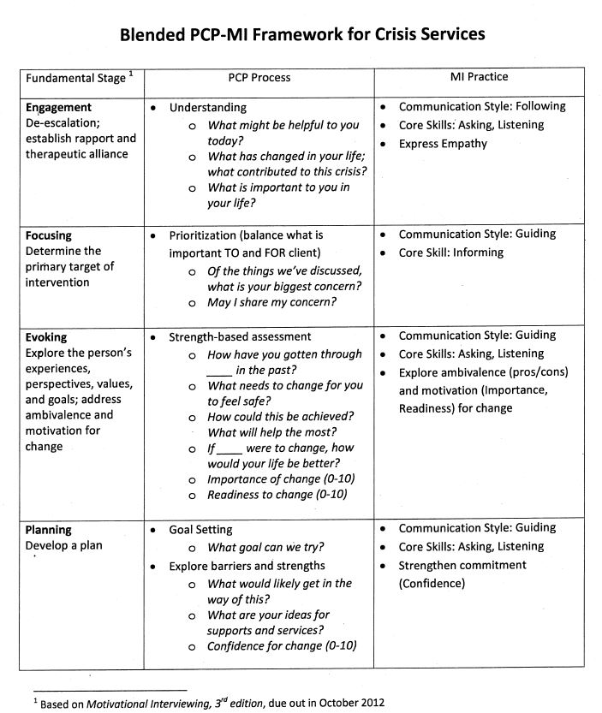

“Person-Centered Planning and Motivational Interviewing: A Framework for Crisis Services”

presentation at Crisis Intervention Conference 2012 – Scott Caldwell and Sola Millard