New Staff Development Model
White Pine Consulting Service, Inc.
8/31/17
- Provider readiness checklist - Identify strengths and needs (staff self-assessment and supervisor review)
- Chart training activities (match provider knowledge with training activities and service action)
- Chart plan for case openings
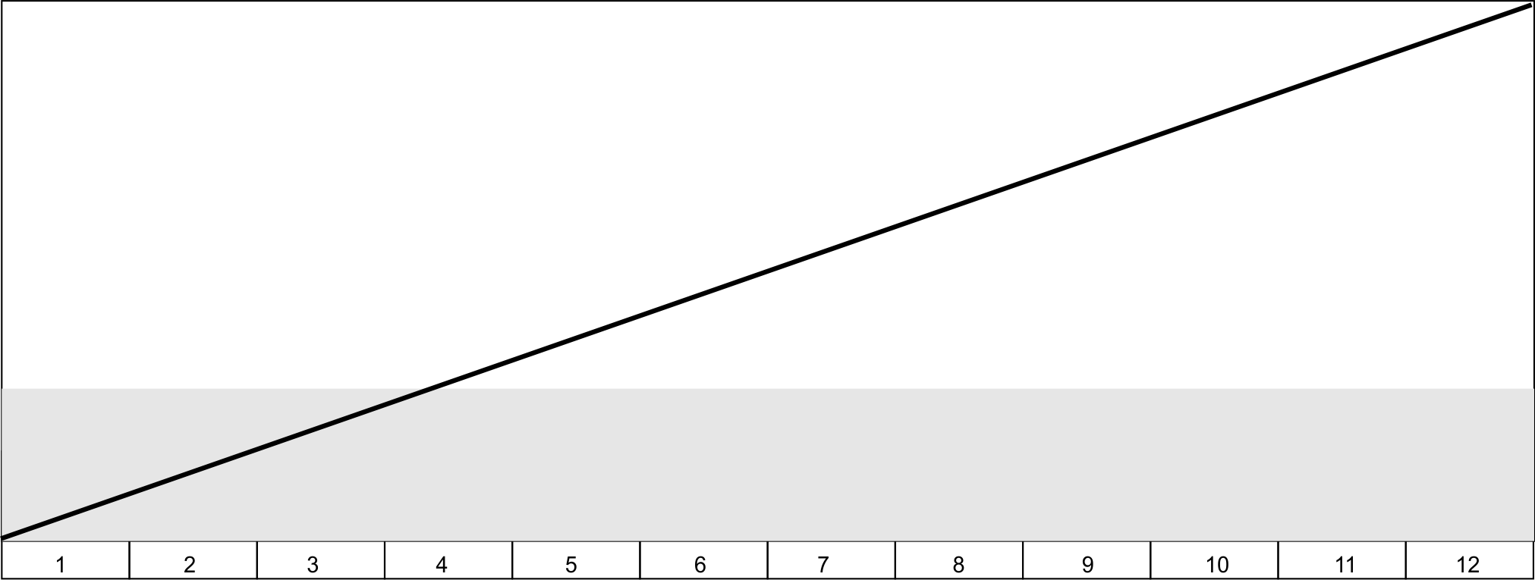
- Review via coaching / supervision
Training Onsite
Webinars / Reading
10 – 12 cases
per FTE
(To be determined by supervisor)

6 cases open
50% billable per FTE
(To be determined by staff and supervisor)

Direct Service
Program Activity
Provider Developmental Continuum
Months
20/40 hours training complete
Leading
Shadowing
Ongoing coaching / supervision

