CST STATEWIDE PROJECT DIRECTORS’ MEETING AGENDA
Wednesday, September 9, 2015
8:30am – 3:45pm
Holiday Inn Hotel and Convention Center

8:30-9:00am  EXPO 3A | Check In and Registration  Refreshments and coffee will be available
9:00am  EXPO 3A | Welcome and Announcements  Teresa Steinmetz, DMHSAS
9:20am  EXPO 3A | Keynote  CST: A Young Adult’s Perspective on the Process  Jerome Deforest-Davis  Tina Day, Rock County Human Services  A young adult from Rock County will tell his story of involvement in CST as a youth, sharing what worked, what didn’t, and ideas on how to engage youth on teams. His former care coordinator will also share her perspective including how the team addressed and overcame obstacles.
10:20am | Break
10:30am | Breakout Sessions
STONEFIELD | - Expanding CST into the Community, Michelle Lloyd, St. Croix Department of Health and Human Services, and Dan Naylor, White Pine Consulting Service  Through sharing and group dialogue the facilitators will guide discussion on how sites can expand their CST initiative from a human service program to a community-wide, sustainable initiative.
EXPO 3A | - CST and CCS, Sally Raschick, DMHSAS and Joanette Robertson, DMHSAS  This session will provide a general overview of CST and Comprehensive Community Services (CCS). The overview will compare and contrast the two programs, as well as allow for discussion on strengths and barriers of working together.
HARVEST | - AODA & Youth Brain Development, Lucas Moore, DMHSAS  This presentation will discuss the development of the adolescent brain and how Substance Use Disorders (SUD) affect the developing brain. This discussion will show those working with adolescents who have an SUD that these consumers are not morally weak, or just making bad decisions; rather they are experiencing a brain disorder that is making their recovery more challenging.
11:40pm  EXPO 3B | Working Lunch - Lunch will be Provided
12:30pm | GROUP A – HARVEST/STONEFIELD  Motivational Interviewing  Laura Saunders, Laura Saunders Consulting | GROUP B – EXPO 3A  Person Centered Planning  Sola Millard, DMHSAS
1:30pm | Break

1:40pm | GROUP A – HARVEST/STONEFIELD  Person Centered Planning  Sola Millard, DMHSAS | GROUP B – EXPO 3A  Motivational Interviewing  Laura Saunders, Laura Saunders Consulting
2:40pm | Break
2:50pm  EXPO 3A | Parent/Youth Panel, facilitated by Dan Naylor, White Pine Consulting Service  A panel of parents with CST team experience will share what they saw as benefits to the team process, what detracted from the process or didn’t work, and recommendations for the future.
3:45pm | Adjourn

Next Statewide Project Directors’ Meeting: Spring 2016, specific date TBD in November 2015

Many thanks to the following people for their ideas, resources, time, and follow through in planning the agenda:

Amy Bahr, Vernon County
Meagen Bublitz, Lac du Flambeau Tribe
Ann Bates, Buffalo, Chippewa, Pepin Counties
Karen Bittner, DMHSAS
Carolyn Blackdeer, Ho Chunk Nation
Julie Butz, Rock County
JoAnn Geiger, Juneau County
Sally Kalkofen, Forest County Potawatomi Tribe
Lori Martin, White Pine Consulting
Joanette Robertson, DMHSAS
Teresa Way, Iron County
Susan Younger, Waupaca County
If you are interested in being involved in planning for the 2016 Project Directors’ Meetings,
please contact Karen Bittner: (608) 267-9308, Karen.bittner@wisconsin.gov.

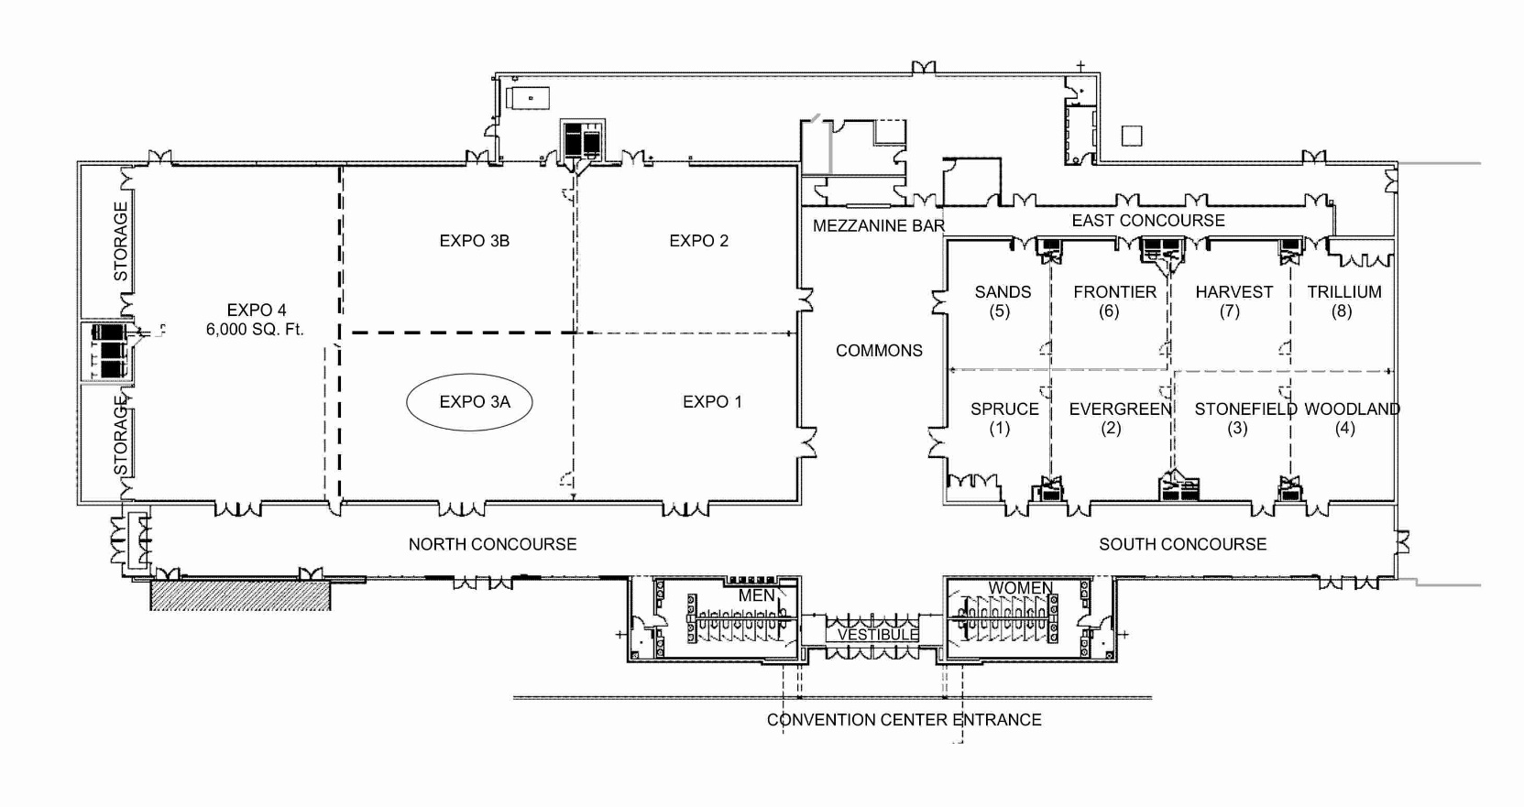
Holiday Inn Convention Center

