UNDERLYING NEEDS AND NEEDS STATEMENTS

Identifying and addressing the underlying needs of children and families is fundamental to our practice. Underlying needs are what drive the behaviors that often worry or challenge us. In many cases, challenging behaviors are the symptoms of unmet needs. In order to be effective, case plans must be individualized and directly address the needs of a child and family – not just the behaviors. Sometimes when we positively reframe problems we get at the need.
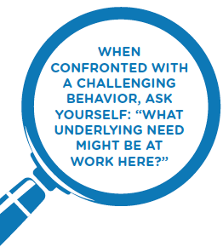
Needs often revolve around SAFETY (children need to feel emotionally and physically safe), WELL-BEING (children may need to talk about their fears or losses), and PERMANENCY (children need to know where they will grow up and need to have a family and community they can call home.)

A need statement:

- Is positively stated in the client’s language or in language that is clear to the client
- Is usually related to one of the fundamental or essential needs of human beings from survival to realization of a dream
- May be a reframe of a problem
- May identify the underlying condition or the source of the behavior
- Helps us to gain greater understanding of the underlying issues related to the behavioral symptoms
- Helps the client envision what would be happening differently when the problem, issue, concern is addressed
- Is prioritized to respond to the issues that may put a youth/family at risk

Needs Statements Are Not

A need statement is not a service or intervention, such as a parenting class or a psychological evaluation; it is not a behaviorally specific statement or a statement of the problem; such as “Jane is acting in a sexually reactive way” or “Susan uses inappropriate discipline methods.” Need statements do not contain timeframes, such as “Jane will achieve a recovery lifestyle within two months” A need statement is not stated negatively, such as “ Susan must attend parenting classes as outlined in the court order or will have consequences.”

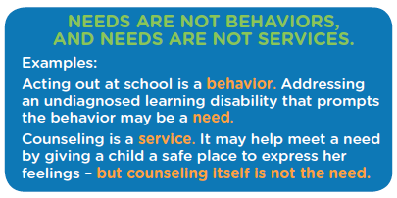
Need statements are not:
- Services/Interventions
- Problem Statements
- Behaviorally Specific Statement
- Negative
- Timeframes

Poor examples of need statements
- Jane (child) needs to go to counseling
- Jane (child) needs to attend school regularly
- Jane (child) needs a psychological evaluation
- Susan (mother) needs a parenting class

How can we identify underlying needs? It all starts with engagement. Be genuinely curious! Ask skillful questions and listen with openness – these are key to uncovering the strengths and underlying needs of the youth and family. Exploring hunches to reach a shared view is also important. Bear in mind that addressing the underlying needs of a child or youth may require addressing the underlying needs of the family, as well.

Coaching questions designed to help team members develop need statements:

What do you think might be going on with that would cause this problem? (For example: If Jane is depressed and not getting up for school, then what need would we have to meet to help Jane, so she can be successful in getting to school more regularly?)

If you believe that counseling would be an appropriate intervention how it will help Jane? What need would be meet? What change would be expected?

Remember: you don’t have to have all the answers! When we team with youth and families and their supports, we can all work to identify underlying needs, and brainstorm individualized plans to meet them.
By partnering with others to identify and respond to underlying needs, families are more likely to enjoy safer and longer-lasting outcomes that help children thrive.

Adapted from Core Practice Model http://dev.gettothecore.org/cpm-tools/thoughts-on-strengths/
Wisconsin Child Welfare Training System, Team Based Practice, 2008

